**How to use the birth rate code**

Written by Meghan Duffy, October 2016 (duffymeg@umich.edu)

**Introduction:**

This code was written by Spencer Hall to calculate birth rates from Daphnia life table data. It was originally written for the Bertram et al. 2013 Oecologia paper, but has been used since then for other datasets, too (including the Searle et al. 2016 Hydrobiologia paper and Searle et al. 2016 AmNat paper). The Bertram et al. and Searle et al. papers contain descriptions of the methods. Here is the information from the supplement of the Searle et al. Hydrobiologia paper:

Supplementary Methods: *b*, *d*, and *r* calculations

We estimated instantaneous birth rate (*b*) and background mortality rate (*d*) for each genotype following methods in Bertram et al. (2013). The birth rate parameter requires estimating both instantaneous per capita population growth rate (*r*) and *d*. Since *r* = *b - d*, birth rate is the sum of *r* and *d*. This method provides us with one value for each genotype. To calculate *r*, we solved the standard Euler-Lotka equation:



where *lt* is the proportion of animals surviving to day *t* and *bt* is the average fecundity on day t.

**The files:**

The code consists of 5 matlab files (meaning: you need access to a machine that has a license for matlab. The lab computer is one option):

calc_d

calc_r_Fx

calc_r_mx

calc_rbd

clone_calc_rbd

The clone_calc_rbd file is the master file that you use. It calls the other files (which you don’t need to modify at all).

**How to arrange your data:**

In order to use the code, you will need to have your data in a text file. That file needs to have the data arranged in a particular way:

1. The first row of the data should be the days of the experiment where the beakers were checked and data on survivorship and reproduction were collected.

2. Each replicate individual is a row below that. The first column of data has a “0” at the top, and then everything below that indicates the clone or treatment or clone*treatment. **This needs to be numeric.** I recommend saving two versions of your data: one where you have an extra first column (or more, if needed) that preserves all the text info on your treatments, matched with the numeric code you gave that clone/treatment/combination. For example, for some of Kristel’s data, the .xlsx file looks like:

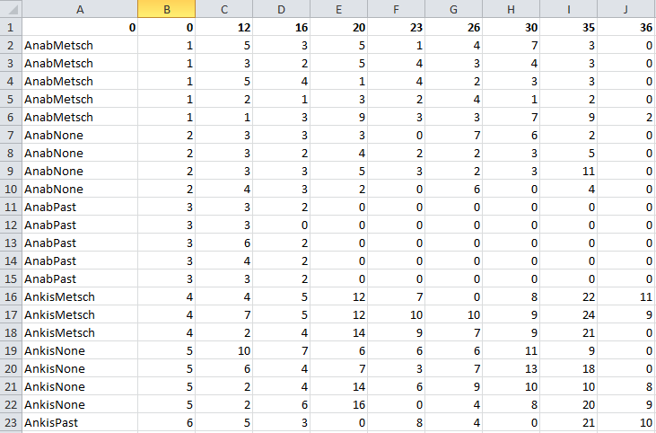

and the .txt file of the same name looks like:

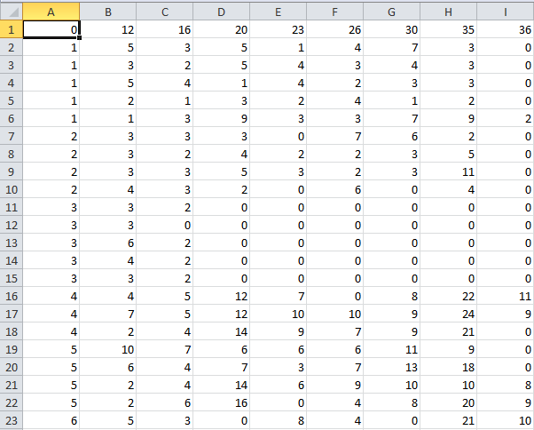

This is very important, as you need to be able to easily pair the output for a given “clone” number to the correct treatment! (Note that the code was originally written to calculate differences between clones, hence “clone” being used throughout. But sometimes we use it to calculate things birth rates of a single genotype fed different foods. In that case, where the code says “clone”, it really means “treatment”.)

3. For each beaker, put the number of offspring found on a given day (as indicated in the top row) in the cell. Some key things:

a. If an animal was dead and did not have offspring, enter “99” in the column on the day she died and for all remaining days.

b. If an animal was dead but released babies, enter 1XX, where the XX is replaced by the number of babies. Or, to put it differently, add 100 to the number of babies that you found, and enter that in the cell for the day on which you found the dead animal and her babies.

c. If the animal lived to the end of the experiment and was sacrificed (i.e., for spore counting), then list the number of babies for the last day of the experiment without a 99 or 1XX.

c. We often make a decision to exclude individuals who didn’t live a certain amount of time (usually something like 1 week). Talk to Meg about that decision, and make sure you take very good notes so you know exactly what you did.

4. Once you’ve done all of the above to format the data, save it as a .txt file. Do not have spaces in the filename. (Use an underscore if needed.)

To give an example of what the data end up looking like, here’s a screen cap of data from one life table:

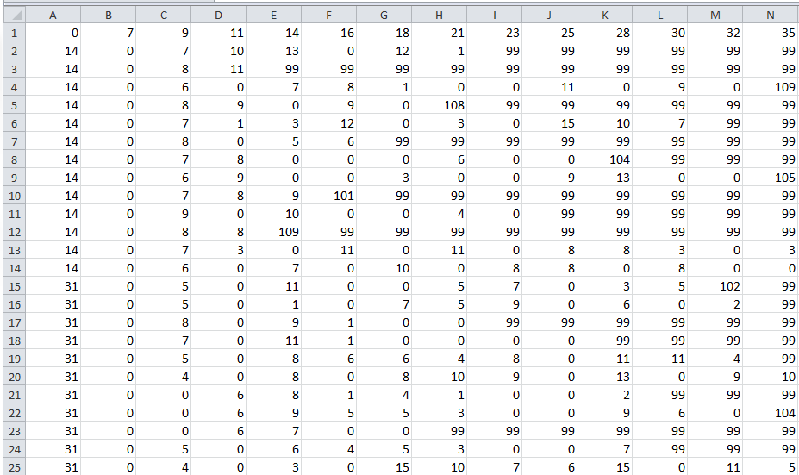

**Calculating *b, d,* and *r***

Now you’re ready to use the code!

1. Open the clone_calc_rbd.m file.

2. Go to line 29. Change the filename there to yourfilename.txt

3. Go to line 30. Change to data = yourfilename (Note: It is intentional that there is no .txt after yourfilename in this line of the code.)

4. Make sure your text file with the data is in the same folder as all the .m files.

5. Go to “Cell” 🡪 “Evaluate Entire File”

6. This will generate a text file with the results (with the name in line 90 of the clone_calc_rbd.m file).

7. In this results file, the first column (A) will be the numeric treatment ID (see point 2 in the previous section). After that, the columns will be:  
 B. b_mx

C. b_Fx (this is a slightly different way of calculating birth rate)

D. r_mx

E. r_Fx (again, slightly different version of *r*)

F. d

G. Mean arithmetic fecundity

H. Mean age at first reproduction

I.-O. Standard errors for the values in B-H, given in the same order.